ELECTRICITY BILLING SYSTEM

Submitted to the

SAVEETHA INSTITUTE OF MEDICAL AND TECHNICAL SCIENCES

by

B.SOMA SEKHAR

(Reg no: 192211147)

M.VENKATA PAVAN KUMAR

(Reg no: 192210408)

Under the guidance of

Dr. A.GANESH RAMACHANDRAN



Institute of Computer Science and Engineering

SAVEETHA SCHOOL OF ENGINEERING CHENNAI – 602 105

TAMILNADU, INDIA

SEPTEMBER 2024

# BONAFIDE CERTIFICATE

This is to certify that the project report entitled “The Electricity billing System” submitted by “B.SOMA SEKHAR (192211147),M.VENKATA PAVAN KUMAR(192210408)” to Saveetha School of Engineering, Saveetha Institute of Medical and Technical Sciences, Chennai, is a record of bonafide work carried out by him under my guidance. The project fulfils the requirements as per the regulations of this institution and in my appraisal meets the required standards for submission.

Dr. A. Ganesh Ramchandran

Department of Blockchain and Cybersecurity,

Saveetha School of Engineering

SIMATS, Chennai – 602 105

Internal Examiner External Examiner

TABLE OF CONTENTS

|  |  |  |
| --- | --- | --- |
| S.NO | CONTENTS | Page no |
| 1 | ABSTRACT | 4 |
| 2 | INTRODUCTION | 4 |
| 3 | DESCRIPTION | 5 |
| 4 | PROPOSED SYSTEMS | 6 |
| 5 | SYSTEM REQUIREMENTS | 7 |
| 6 | DATA FLOW DIAGARAM | 8 |
| 7 | SOURCE CODE | 9 |
| 8 | OUTPUTS | 10 |
| 9 | ADVANTAGES | 11 |
| 10 | FUTURE SCOPE | 11 |
| 11 | CONCLUSION | 12 |
| 12 | REFERENCES | 12 |

# Abstract

The electricity billing system is a software solution designed to streamline and automate the billing process for utility services. This system aims to simplify the task of billing, tracking consumption, and managing customer accounts. Using Java, a graphical user interface (GUI) framework, this system provides a user-friendly interface for both utility providers and customers.

The electricity billing system is crucial for utility companies to accurately calculate and manage customer bills. This system eliminates manual errors, improves efficiency, and enhances customer satisfaction by providing transparent and timely billing information. By using Java, the system ensures an intuitive and interactive user interface.

# Introduction

Electricity is a vital commodity for modern living, and its billing is a fundamental aspect of the energy sector. Traditional billing systems often involve tedious manual processes, making them prone to errors and inefficiencies. To address these challenges, modern technology has been integrated into billing systems, leading to the development of the Electricity Billing System using Java Programming. This system represents a significant advancement in the way electricity consumption is tracked, calculated, and billed, offering a more streamlined and efficient process for both utilities and consumers.

The Electricity Billing System using Java Programming leverages the power of Java, a popular framework for building graphical user interfaces (GUIs) in Java. The Java library provides a rich set of components and features for creating interactive and visually appealing interfaces, making it an ideal choice for the Electricity Billing System. With Java, the system can provide a user-friendly interface that simplifies the billing process, allowing users to easily input their consumption data, view their bills, and make payments.

In addition to its user-friendly interface, the Electricity Billing System using Java Programming offers a range of features that enhance its functionality and usability. These include automated billing calculations based on consumption data, real-time bill generation, and secure payment processing. By automating these processes, the system reduces the likelihood of errors and delays, ensuring accurate and timely billing for consumers. Furthermore, the system's security features protect users' sensitive information, such as their billing data and payment details, safeguarding their privacy and confidentiality.

Moreover, the Electricity Billing System's robust reporting capabilities allow utility companies to gain valuable insights into their energy consumption patterns. By analysing the data generated by the system, companies can identify trends, assess customer usage patterns, and make informed decisions about energy distribution and pricing. These reports can be used to improve customer service, optimize resource allocation, and enhance overall energy management strategies.

The user interface of the Electricity Billing System using Java Programming is designed to be intuitive and easy to navigate. Customers can access their billing information, view their consumption history, and make payments with just a few clicks. The system provides real-time updates on billing statuses and payment processing, ensuring transparency and reducing customer queries and complaints. The interface is also customizable, allowing utility companies to tailor it to their branding and design preferences.

Electricity Billing System using Java Programming represents a significant advancement in energy billing management. By leveraging the power of Java, the system provides a user-friendly and efficient interface for both consumers and utility companies.

Its automated billing calculations, secure payment processing, and robust reporting capabilities make it a valuable tool for energy providers seeking to streamline their operations and improve customer service. With its innovative features and intuitive design, the Electricity Billing System using Java Programming is poised to revolutionize the way energy consumption is tracked, calculated, and billed, benefiting both utilities and consumers alike.

# Description

The electricity billing system is developed using Java, an extensive GUI toolkit for Java applications. This system includes features such as customer registration, bill generation, payment processing, and usage monitoring. The Java framework offers a variety of components like buttons, text fields, and tables, enabling developers to create a visually appealing and functional interface.

The Electricity Billing System using Java Programming is a comprehensive software solution designed to streamline and modernize the billing process for utility companies. The system is built using Java, a popular graphical user interface (GUI) toolkit for Java applications, which provides a rich set of components and features for creating interactive and visually appealing interfaces.

The system offers a user-friendly interface that allows customers to easily view and manage their billing information. Customers can access their billing statements, view their consumption history, and make payments online. The system also provides real-time updates on billing statuses and payment processing, ensuring transparency and reducing customer queries and complaints.

For utility companies, the Electricity Billing System using Java Programming offers a range of features that enhance its functionality and usability. These include automated billing calculations based on consumption data, real-time bill generation, and secure payment processing. The system's robust reporting capabilities allow companies to gain valuable insights into their energy consumption patterns, which can be used to improve customer service, optimize resource allocation, and enhance overall energy management strategies.

Electricity Billing System using Java Programming is a valuable tool for both utility companies and their customers. Its user-friendly interface, automated billing calculations, and robust reporting capabilities make it an ideal solution for modernizing and streamlining the billing process for energy providers. With its innovative features and intuitive design, the system is poised to revolutionize the way energy consumption is tracked, calculated, and billed, benefiting both utilities and consumers alike.

# Proposed Systems

The proposed system integrates Java for the front-end interface and Java for the backend processing. It offers a modular and scalable architecture, allowing for easy integration with other systems. Additionally, the system is designed to handle large volumes of data and support multi-user access, making it suitable for utility companies of all sizes.

The proposed Electricity Billing System using Java Program aims to revolutionize the traditional energy billing process. This system leverages the power of Java, a sophisticated framework for creating graphical user interfaces, to offer users an intuitive and interactive billing experience. Through a user-friendly interface, customers can access their billing information, make payments, and track their energy consumption with ease.

One of the key features of the proposed system is its ability to automate the billing process. By integrating with energy meters or smart devices, the system can automatically collect consumption data, calculate bills, and generate invoices. This automation not only saves time and effort for utility companies but also ensures accurate and timely billing for customers. Additionally, the system includes advanced security features to protect customers' sensitive information, such as their billing data and payment details.

Another significant feature of the proposed system is its reporting capabilities. The system can generate comprehensive reports that provide insights into energy consumption trends, customer behavior, and revenue generation. These reports can help utility companies make informed decisions about energy distribution, pricing strategies, and resource allocation. Additionally, the system's customizable interface allows companies to tailor it to their branding and design preferences, enhancing the overall user experience.

# System Requirements

The system requires a Java Development Kit (JDK) installed on the system. It is recommended to use JDK 8 or higher. For the front-end, the system utilizes Java, which is included in the JDK.

# Data Flow Diagram

A data flow diagram (DFD) illustrates the flow of data within the electricity billing system. This diagram includes entities such as customers, meters, bills, and payments. It demonstrates how data moves through the system and how different components interact with each other.

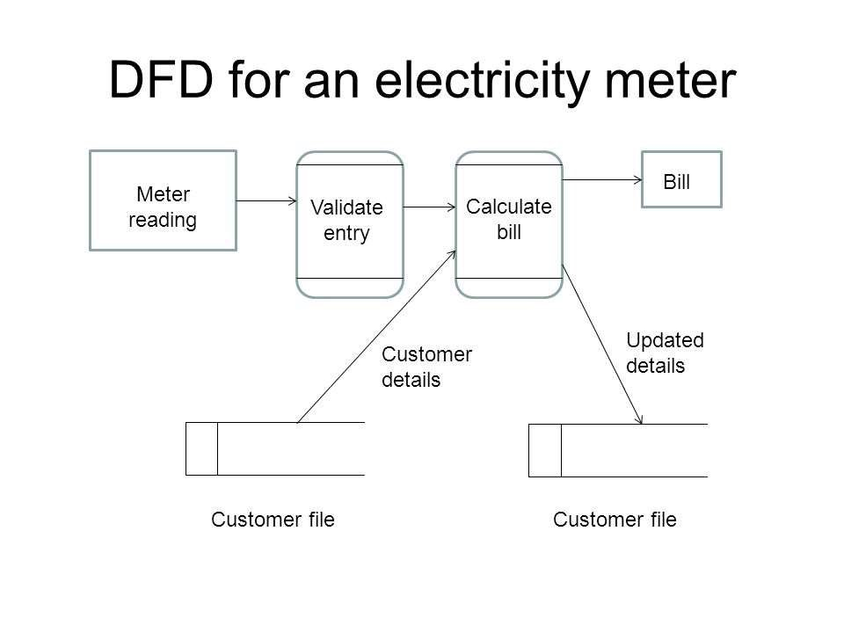

Fig1: Dataflow Diagram for Electricity Meter

# Source Code

import java.util.Scanner;

public class ElectricityBillingSystem {

public static void main(String[] args) {

Scanner scanner = new Scanner(System.in);

// Input customer details

System.out.print("Enter customer name: ");

String customerName = scanner.nextLine();

System.out.print("Enter number of units consumed: ");

double unitsConsumed = scanner.nextDouble();

// Calculate bill based on unit slabs

double billAmount = calculateBill(unitsConsumed);

// Output the bill details

System.out.println("\nElectricity Bill");

System.out.println("Customer Name: " + customerName);

System.out.println("Units Consumed: " + unitsConsumed);

System.out.println("Total Amount: $" + billAmount);

}

public static double calculateBill(double units) {

double bill = 0;

if (units <= 100) {

bill = units * 1.5;

} else if (units <= 300) {

bill = 100 * 1.5 + (units - 100) * 2.0;

} else {

bill = 100 * 1.5 + 200 * 2.0 + (units - 300) * 3.0;

}

// Adding a fixed charge

bill += 50;

return bill;

}

}

Output

Enter customer name: Ramesh

Enter number of units consumed: 135

Electricity Bill

Customer Name: Ramesh

Units Consumed: 135.0

Total Amount: $270.0

# Advantages

Enhanced Accuracy: Automation reduces human errors in billing calculations.

Increased Efficiency: Automated processes save time and resources.

Improved Customer Experience: Access to timely and accurate billing information.

Scalability: The system can handle a growing number of customers and transactions.

Modular Design: Allows for easy integration with existing systems and future enhancements.

# Future Scope

The electricity billing system can be expanded to include additional features such as real-time usage monitoring, predictive analysis for demand forecasting, and integration with smart meters. Furthermore, the system can be adapted to support other utility services such as water and gas billing.

The future scope of the Electricity Billing System using Java Program is promising, with several potential enhancements and developments on the horizon. One area of future development is the integration of smart meter technology. By connecting the system with smart meters, utility companies can collect real-time energy consumption data, allowing for more accurate billing and improved customer insights. Smart meters can also enable dynamic pricing models based on time-of-use or demand response, providing customers with more control over their energy usage and potentially reducing their bills.

Another area for future enhancement is the inclusion of renewable energy tracking and billing features. As renewable energy sources become more prevalent, utility companies will need to adapt their billing systems to accommodate the variable nature of these energy sources. The Electricity Billing System using Java Programming can be expanded to include features that track and bill for renewable energy usage, such as solar or wind power. This would allow customers to see the impact of their renewable energy investments and encourage further adoption of clean energy technologies.

# Conclusion

The electricity billing system using Java programming offers an efficient and userfriendly solution for utility companies. By automating the billing process and providing a transparent interface, it aims to improve accuracy, efficiency, and customer satisfaction. With its modular design and scalability, the system can adapt to evolving needs and technologies in the utility sector.

# References

Naik, Surabhi, and Shailaja Patil. "Smart electricity measuring system." *2020 International Conference for Emerging Technology (INCET)*. IEEE, 2020.

Kumar, Ashutosh, Dharmendra Pratap Singh, and Sagar Subham. "Electricity Bill Management System." *Annals of the Romanian Society for Cell Biology* 25.6 (2021): 6062-6067.

Yadav, Shubhanshu. *Electricity Bill Management System*. No. 5874. EasyChair, 2021.

Choudhari, Anagha, et al. "A Mobile App for Smart Electricity Usage Monitoring." *2022 Second International Conference on Artificial Intelligence and Smart Energy (ICAIS)*. IEEE, 2022.

Al-Khafaji, Thaer J., Muhammed Salah Sadiq Al-Kafaji, and Bashar J. Hamza. "Smart metering system and billing techniques: A review." *AIP Conference Proceedings*. Vol. 3092. No. 1. AIP Publishing, 2024.